Log in to Permit by Rule database

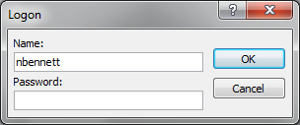

Click on Open Database in Edit Mode

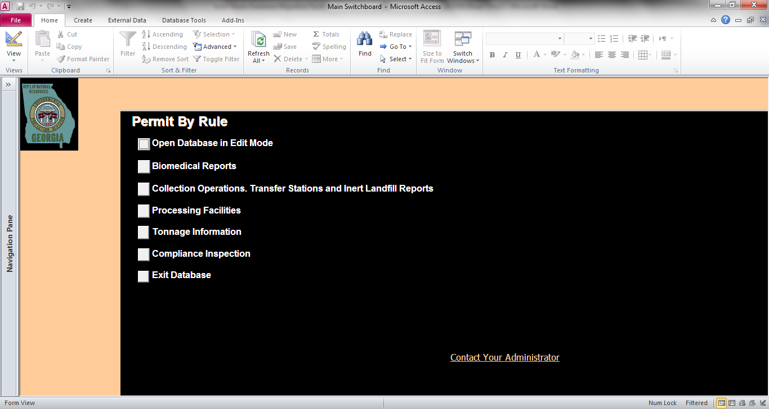

Click on Open Database in Edit Mode

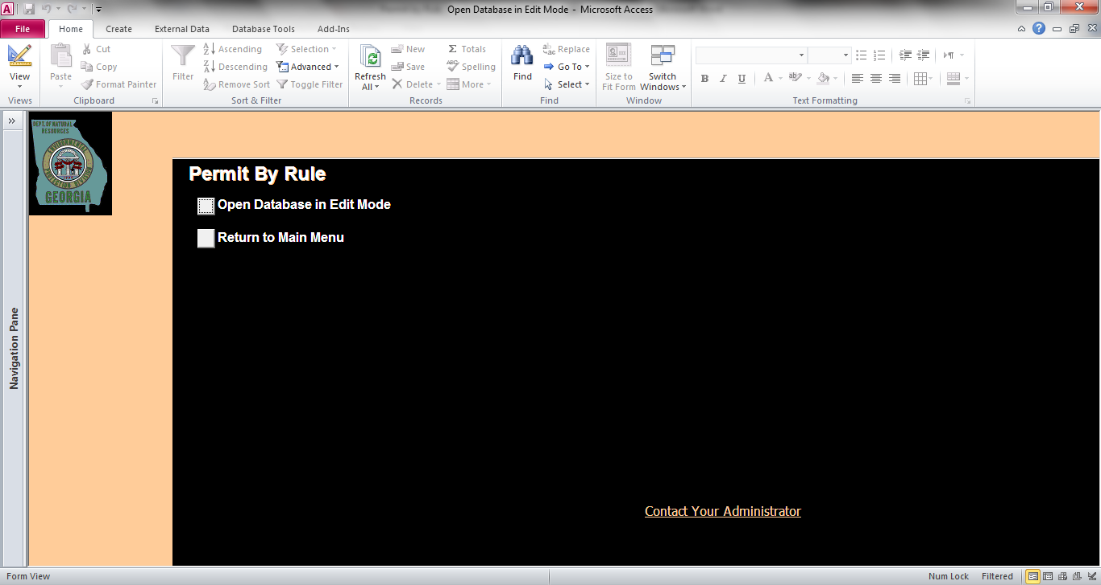

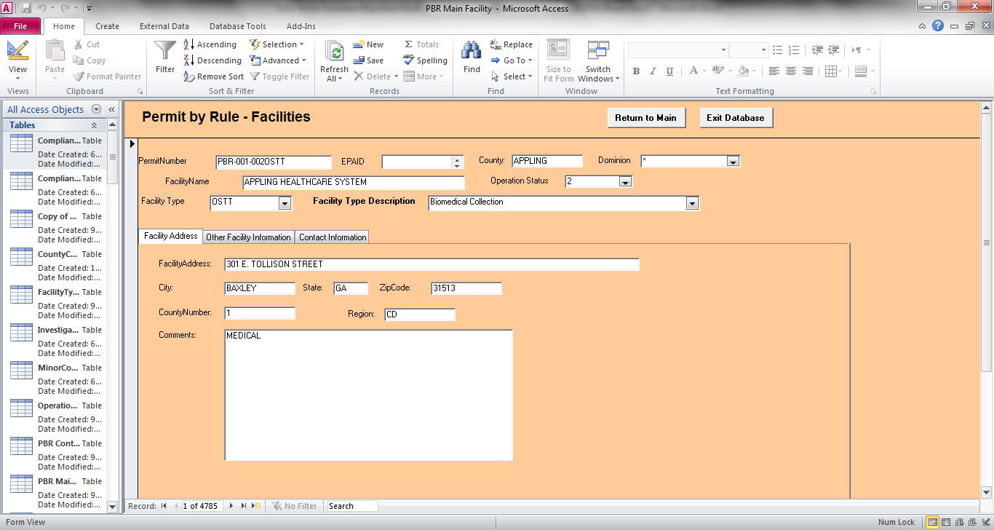

Access the data in table format

Toolbar used for queries

1. Permit Number, County, Facility Name, Operation Status, Facility Type and Facility Type Description are important fields to be migrated.

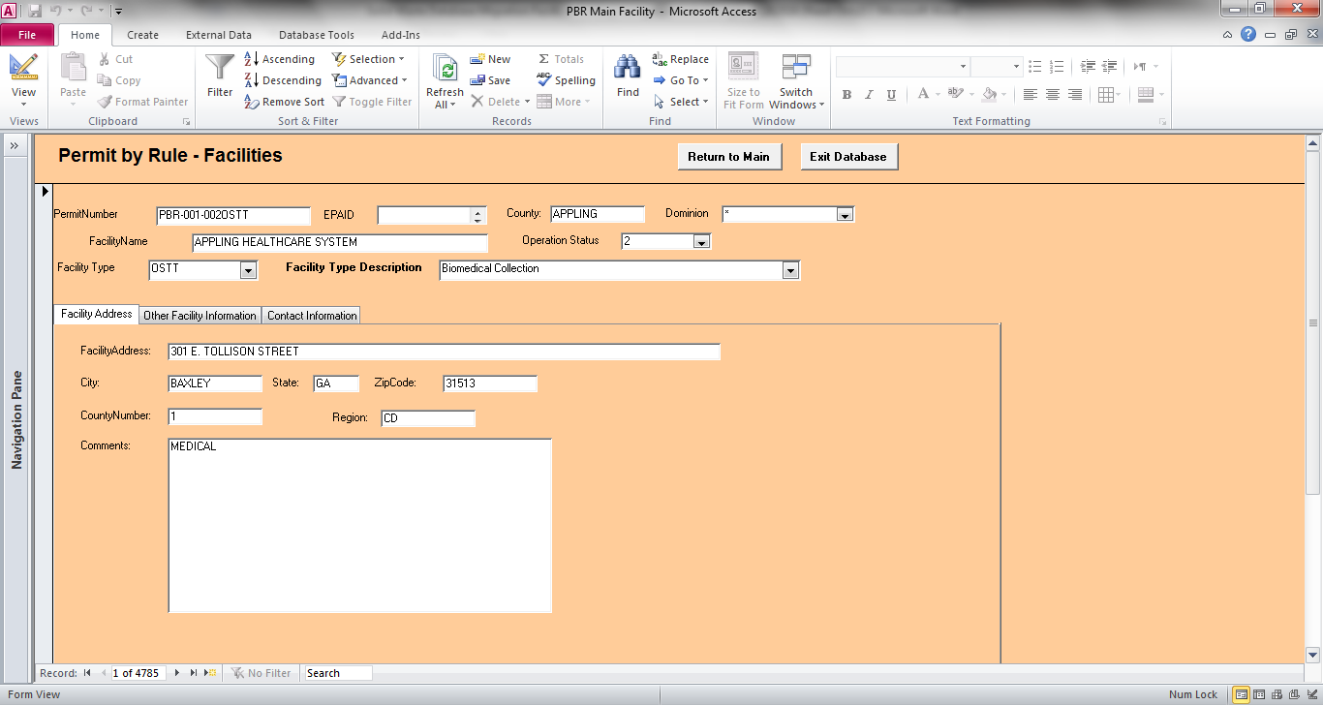

Important Fields to be migrated

1. Remove EPAID and Dominion.

Remove



1. Operation Status has inputs that are incorrectly labelled. Consider correcting.

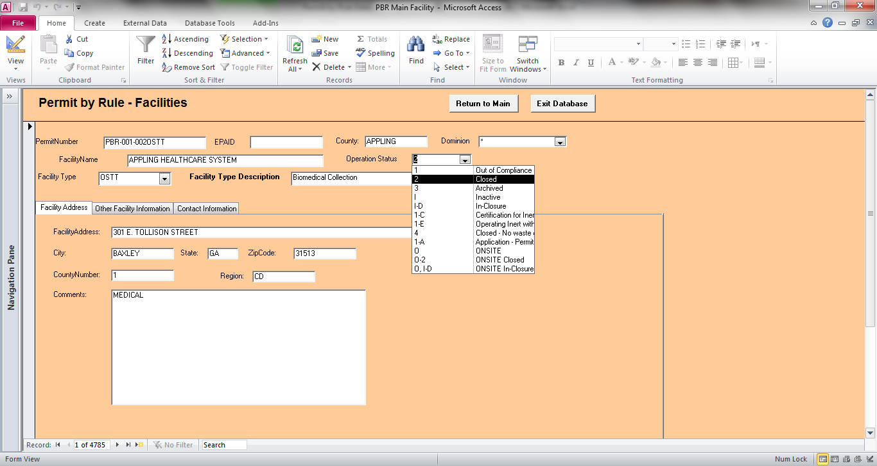

Operation Status will be migrated but it needs corrections

|  |  |  |  |
| --- | --- | --- | --- |
| Operation Status | Operation Status Description | Operation Status | Operation Status Description |
| 1 | Out of Compliance - Closure Documentation Needed | 1-E | Operating Inert with Extension Approval |
| 2 | Closed | 4 | Closed - No waste onsite |
| 3 | Archived | 1-A | Application - Permit Applied For |
| I | Inactive | O | ONSITE |
| I-D | In-Closure | O-2 | ONSITE Closed |
| 1-C | Certification for Inert LF | O, I-D | ONSITE In-Closure |

Permit by Rule – Facilities has three tabs:

* Facility Address
* Other Facility Information
* Contact Information

1. The Facility Address, City, State and Zip Code are important fields to be migrated in the Facility Address tab.



* Facility Address
* City
* State
* Zip Code

Are important fields to be migrated

1. Remove County Number and Region

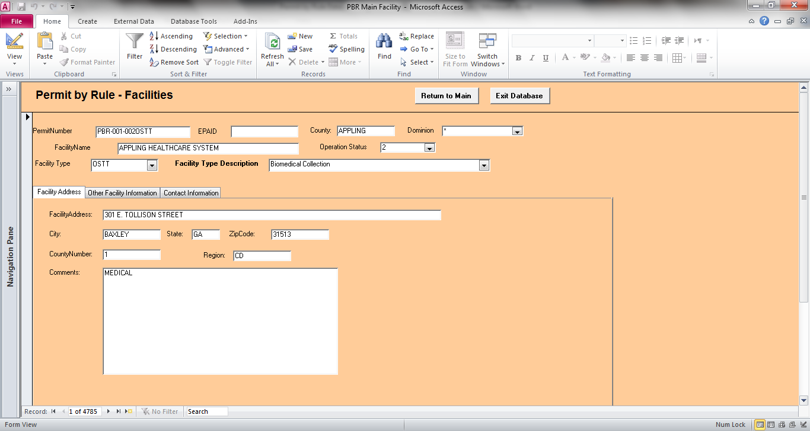

Remove

1. The Comments field is important and will be migrated.



Migrate the Comments field